11.02
Shop Card Templates
Process Design & AMOS Configuration Document
Purpose
This Process Design document is provided to Key-Users to record their key decisions regarding the AMOS Process design and the required AMOS configuration.
It is updated throughout the Project Definition Phase and used as the baseline for the Final Acceptance prior to Go-Live
Revision
Author, Name | Date | Notes
Marcel Moser | 01.06.2024 | First version

Table of Contents
1. Process Overview & Objectives 3
2. Regulatory References 4
3. Definitions & Glossary 4
4. Process Tasks 4
5. Process Dependencies 5
6. Process Flow 6
7. Process Design Questions 7
8. Data (Source) Mapping 8
9. Other Software Used 8
10. AMOS Configuration 9
a. Basic Data 9
b. Parameters 9
c. Workflows 10
d. Scheduled Tasks 10
e. API’s & Interfaces 10
11. Annex – Additional Info 10

Process Overview & Objectives

Process General Description:
This process is usually executed by the Shop Engineering or Shop Planning department of an MRO.
The work template authoring process is a requirement to then be able to properly plan and execute maintenance events in AMOS. This process is continuously executed as it is run both at the initial creation of the work templates and at their revision.
The trigger for this process is the need to create or modify a work template for maintenance execution, and the output of this process are the work templates ready for planning and/or execution.
The main benefits identified for the organisation when fully adopting this process are the following:
- Overall, Economy – cost reduction: As work templates are basically driving all the planning data and, consequently, also the planned allocation of resources, it is clear that accurate data will bring to an increase of the efficiency and to a consequent reduction of costs. In fact, accurate work templates will on one side protect the organization from the disruptions potentially caused by an under-estimation of the needed resources, on the other side will avoid potential inefficiencies in terms of financial budget, caused by an over-allocation of resources. Moreover, the accuracy of the work instructions, will avoid work interruptions and waste of manpower.
- Process improvement: If the work templates are accurate, the maintenance preparation and execution will be properly driven to the best standards.
- Internal management: With accurate work templates, the manpower both in engineering and maintenance will be optimized as this will reduce the interactions generated by unclear or incomplete information during the operational management.
- It is important to clearly define appropriate user access rights to the associated APNs as the maintenance program APN is very sensitive with regards to the airworthiness of the aircraft managed inside.
- The work template authoring policy inside the organisation should clearly specify which department is responsible of which work template elements.

Main Process Objective (Outputs & Outcomes):
The main stake holder involved in this process is the Shop Engineering or Shop Planning department. This department is usually responsible for authoring the work instructions and updating them when required.
- Shop Engineering/Planning is also usually the department that collects feedback on the work templates to continuously improve them.
- Work template creation and authoring is usually performed by users that have maintenance planning and maintenance execution experience. This allows them to efficiently create accurate templates that can easily be used in productive environments.
- Maintaining the work templates is an on-going process that requires continuous involvement of the department. The workload to setup the templates is usually high at the first implementation, but then reduces significantly when only revisions are required.
- The validation of the work templates after their creation may involve different level of users within the Production Engineering/Planning department.
- It is important to note that the CAMO/Engineering department is also involved in this process, as the creation and initialisation of an AMP event creates a basic work template that is associated to the event.

Regulatory References

- EASA Part-145, Regulation (EU) No. 1321/2014
  - Sections: 145.A.45/65
- FAA 14 CFR Part 145
  - Sections: 145.51/.109/.211

Definitions & Glossary

Keywords | Explanation
Shopcard | Detailed work instructions describing how the component maintenance needs to be performed, listing required qualification to execute the work, material and duration of the service.
Component Requirement | The service that needs to be performed as stated by technical documentation provided by the manufacturer or customer.
Work Template | Work Template is a re-usable set of work steps that can be added to any plannable event in AMOS

Process Tasks

Business Process Task / Actions / Activities:
The following actions are performed in this Business Process:
- Prepare Work Template – Standalone/Customer Requirement / Component Requirement: Generate a work template from scratch, without any information coming from manage aircraft maintenance program.
- This is done for customer requirements and is applicable to MROs maintaining 3rd party aircraft.
- This is also done for standalone work templates that can be prepared for ad-hoc events such as findings.
- This can also be done for component requirements which are linked to ad-hoc events such as shop work.
- In this action the user will generate a template linked to a specific scope (mainly the CMM, link the relevant OEM document to it, add his resource requests including parts, tools, and staff. The user should also add the relevant phases to the template.
- Create draft EWI: This step is optional: When using EWIs, work templates offer the possibility to create a draft EWIs for each individual work templates. Creating a draft EWI offers the possibility to customise the EWI before it is used in a work package. During this step the user can add additional information to the EWI, mark items as N/A, add additional stamp boxes etc... These elements will be carried over with the work template in the Workpackage.
- Activate revision of the work template: In this step the suer finalises the authoring of the work template and by activating the revision, put into production all the changes brought to the work template.

Process Dependencies

- 02.05 – Technical Library: to be able to link documentation references inside your work templates, the documentation needs to be imported in the OEM documentation library before.
- 11.04 – Component Maintenance: to enable execution of Component Workpackages
- 11.06 – Component Release: to enable the Release to Service of Component Workpackages

Process Flow
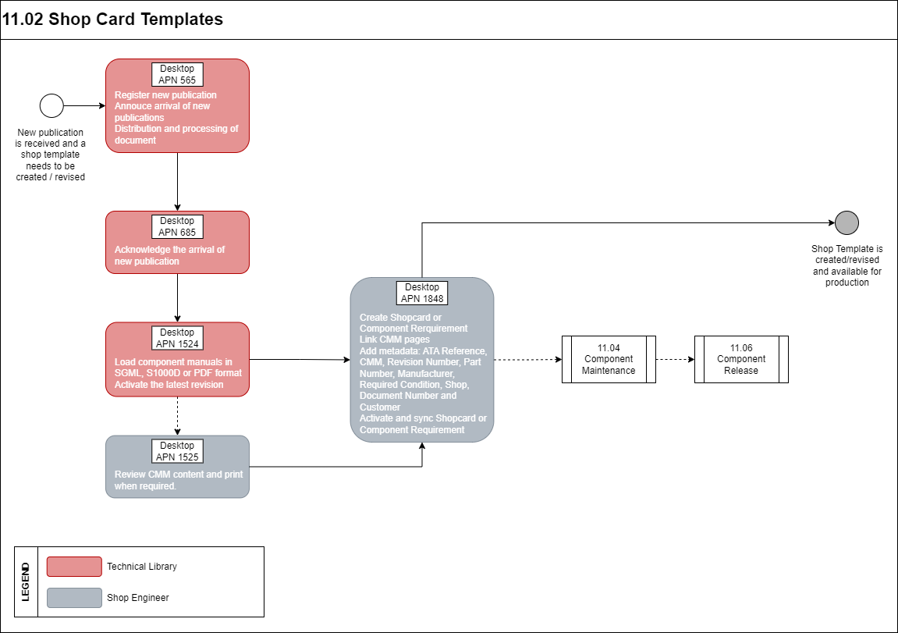

Process Design Questions

# | Question | Answer
1 | In your company which department oversees the creation the work instructions?
2 | When changes are performed to a work instruction of a task that is currently being performed by the production, what is procedure to inform the mechanics?
3 | What is the revision process for work instructions. does the mechanics have to perform the job with the latest version or with the printed one?
4 | What is the feedback process from the production line? How can a shop worker inform the dedicated department in charge of creating work instruction that some tasks need to be changed?
5 | Does the estimated M/H is considered as part of the work instruction to help mechanics to perform the task.

Data (Source) Mapping

Data Sources | Description | Volume / Manual / Automatic / Static / Dynamic
XWORKTEMPLATE | Generic Worktemplate Transfer

Other Software Used

Other Software | Used by: | Description

AMOS Configuration

Basic Data

Basic Data Table | Notes
ATA Chapter | It is prefilled with the standard chapters. The ATA chapter is a string divided in four blocks. The format for an ATA chapter
Phase | Phase is used to categorize Work Steps by the stage of action in which they are performed.
Planning Qualifications | To define Skill and Scope by staff specialty or qualification to properly perform a work instruction.  Skill e.g.: C, B1, B2, etc.  Scope: Mech., EIR, Cabin,
Meta Data Key | Basic Table to define the applicable meta keys which can be used when defining new meta data.  If a `Mime type` is added the user can choose the meta data value via book when adding a value
Standard Text | Defines replacements for the @STANDARD_TEXT@ and @STANDARD_HEADLINE@ wildcards of a work template.

Parameters

Parameter Code | Parameter Name | Notes
1805 | Default Rounding Strategy for Resource Time Requirement | This parameter defines the default strategy used to round the time requirement in Quotation Manager, in the Commercial Tab of Worktemplate manager and in Define commercial Man-Hours.
1878 | Work Step Wildcards Behavior | None.

Workflows

Workflow Number | Workflow Name | Notes
230 | Worktemplate Modification | The workflow will be triggered whenever a Work Template is modified.
390 | Work Template Update Revision | The workflow will be triggered when 'Update Revision' function is performed.

Scheduled Tasks

Scheduled Task Reference | Frequency | Notes
WorkTemplateActivateRevisionService | Once on demand e.g., after initial Data-Transfer | This service activates all work templates where only a NEW Revision exists. In addition, the revision number is set to 0 for hidden work templates with event_template. status = 9 ('INACTIVE')

API’s & Interfaces

Reference | Direction | Trigger | Frequency

Annex – Additional Info

N/A

